I
n this session we will look at how process definition are being versioned in camunda?.

Business Processes are by nature long running. The process instances will maybe last for weeks, or months. In the meantime the state of the process instance is stored to the database. But sooner or later you might want to change the process definition even if there are still running instances.

Camunda Process Versioning

Process versioning is supported by the process engine:
- If you publish a changed process definition, you get a new version in the database.
- Running process instances will continue to run in the version they were started in.
- New process instances will run in the new version - unless specified explicitly.
- Support for migrating process instances to new a version is supported within certain limits.

Check process version
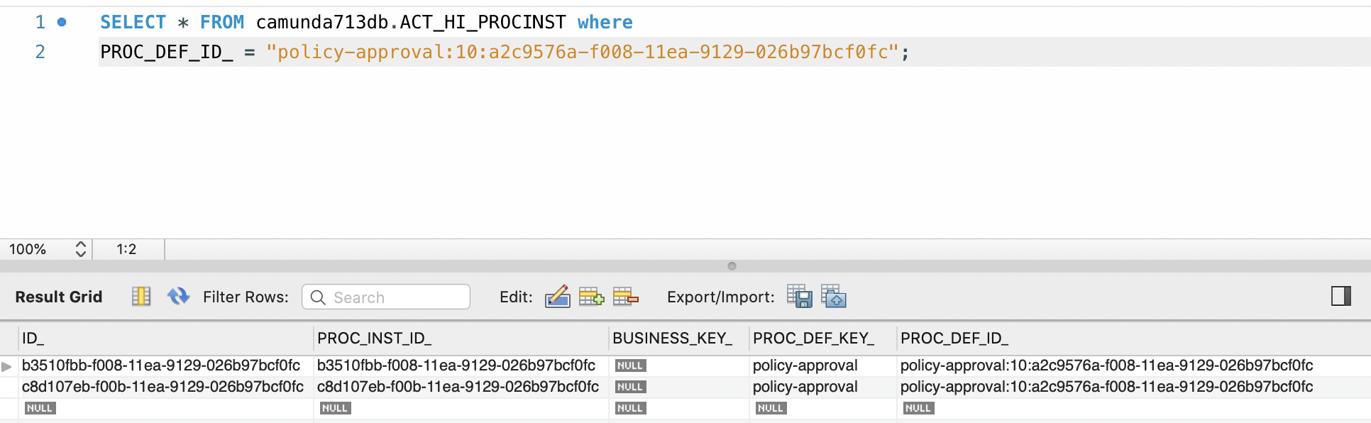
Process instances linked to specific process definition version

Which process definition version will be used

When you start a process instance
- By key: It starts an instance of the latest deployed version of the process definition with the key.
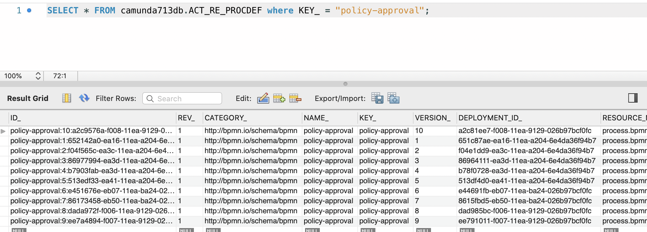
- By id: It starts an instance of the deployed process definition with the database id. By using this you can start a specific version.

The default and recommended usage is to use startProcessInstanceByKey and always use the latest version:
processEngine.getRuntimeService().startProcessInstanceByKey("policy-approval");

If you want to

specifically start an instance of an old process definition, use a Process Definition Query to find the correct ProcessDefinition id and use startProcessInstanceById:

ProcessDefinition pd = processEngine.getRepositoryService().createProcessDefinitionQuery()
.processDefinitionKey("policy-approval")
.processDefinitionVersion(9).singleResult();
processEngine.getRuntimeService().startProcessInstanceById(pd.getId());

Above code will start the process definition with key policy-approval and version 9. I.e id = policy-approval:9:ee7a4894-f007-11ea-9129-026b97bcf0fc

Specify process definition with specific version in BPMN call activity

<callActivity id="callSubProcess" calledElement="checkCreditProcess"
camunda:calledElementBinding="latest|deployment|version"
camunda:calledElementVersion="17">
</callActivity>

The options are
- latest: Use the latest version of the process definition (as with startProcessInstanceByKey).
- deployment: Use the process definition in the version matching the version of the calling process. This works if they are deployed within one deployment - as they are then always versioned together (see Process Application Deployment for more details).
- version: Specify the version hard coded in the XML.
- versionTag: Specify the versionTag hard coded in the XML.

Key vs ID

Key: The key is the unique identifier of the process definition in the XML, so its value is read from the id attribute in the XML:

<bpmn:process id="policy-approval" name="payment process error handing bpmn error" isExecutable=“true”>

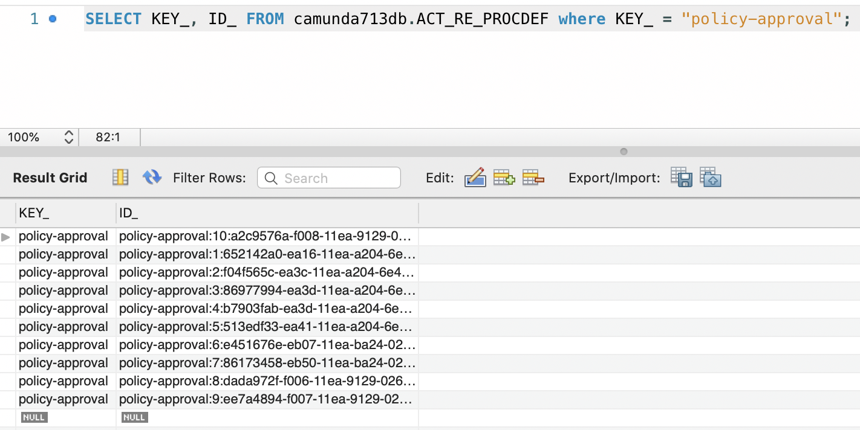
Id: The id is the database primary key and an artificial key normally combined out of the key, the version and a generated id (note that the ID may be shortened to fit into the database column, so there is no guarantee that the id is built this way).

Version Tag

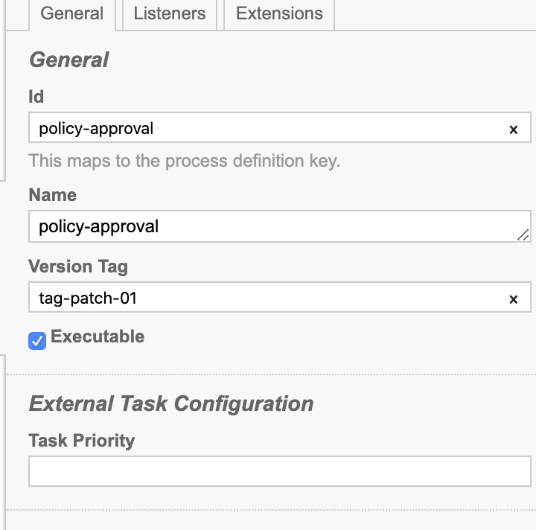
We can tag a process definition with a version tag attribute. This can be done by adding the camunda:versionTag extension attribute to the process:

<bpmn:process id="policy-approval" name="policy-approval" isExecutable="true" camunda:versionTag="tag-patch-01">

Fetch process definition’s version tag.
ProcessDefinition pd = processEngine.getRepositoryService().createProcessDefinitionQuery()
.processDefinitionKey("invoice")
.processDefinitionVersion(1).singleResult();

pd.getVersionTag();

Fetch process definition by version tag.
List<ProcessDefinition> pdList = processEngine.getRepositoryService().createProcessDefinitionQuery()
.versionTag("1.5-patch2")
.list();

Fetch process definition by versionTagLike to query for a range of versions:
List<ProcessDefinition> pdList = processEngine.getRepositoryService().createProcessDefinitionQuery()
.versionTagLike("1.5-%")
.list();

